**Basketball reference scraper**

**Goal**: Write python script to pull in game and player box score data for all NBA games since the 2000-2001 season and output data as .csv. Both the python script and csv are deliverables.

**Deliverables**:

1. Write python script to pull team and player data from [https://www.basketball-reference.com](https://www.basketball-reference.com/) for all seasons since 2000-2001. The flow of code should be the following (using season 2016-2017 as an example):
   1. Iterate through every month (starting with October) with the following URL: <https://www.basketball-reference.com/leagues/NBA_2017_games-october.html> and obtain the following details: Date (to be separated into Date and Day), Start,Visitor/Neutral, PTS, Home/Neutral, PTS, Attend (see Figure 1)
   2. For every game, enter the ‘Box score’ URL (eg, <https://www.basketball-reference.com/boxscores/201610250CLE.html>) and obtain the following stats:
      1. Line score for Q1, Q2, Q3, Q4, (OT if applicable, if empty just leave cells blank)
      2. Away team players all basic stats
      3. Away team players all advanced stats
      4. Home team players all basic stats
      5. Home team players all advanced stats

(see Figure 2)

1. Output as CSV with each game represented in a separate row with appropriate column headers as per the attached csv file.

If a team has less than 18 players, just leave all the remaining cells blank.

For players that ‘Did not play’, just leave the cells blank.

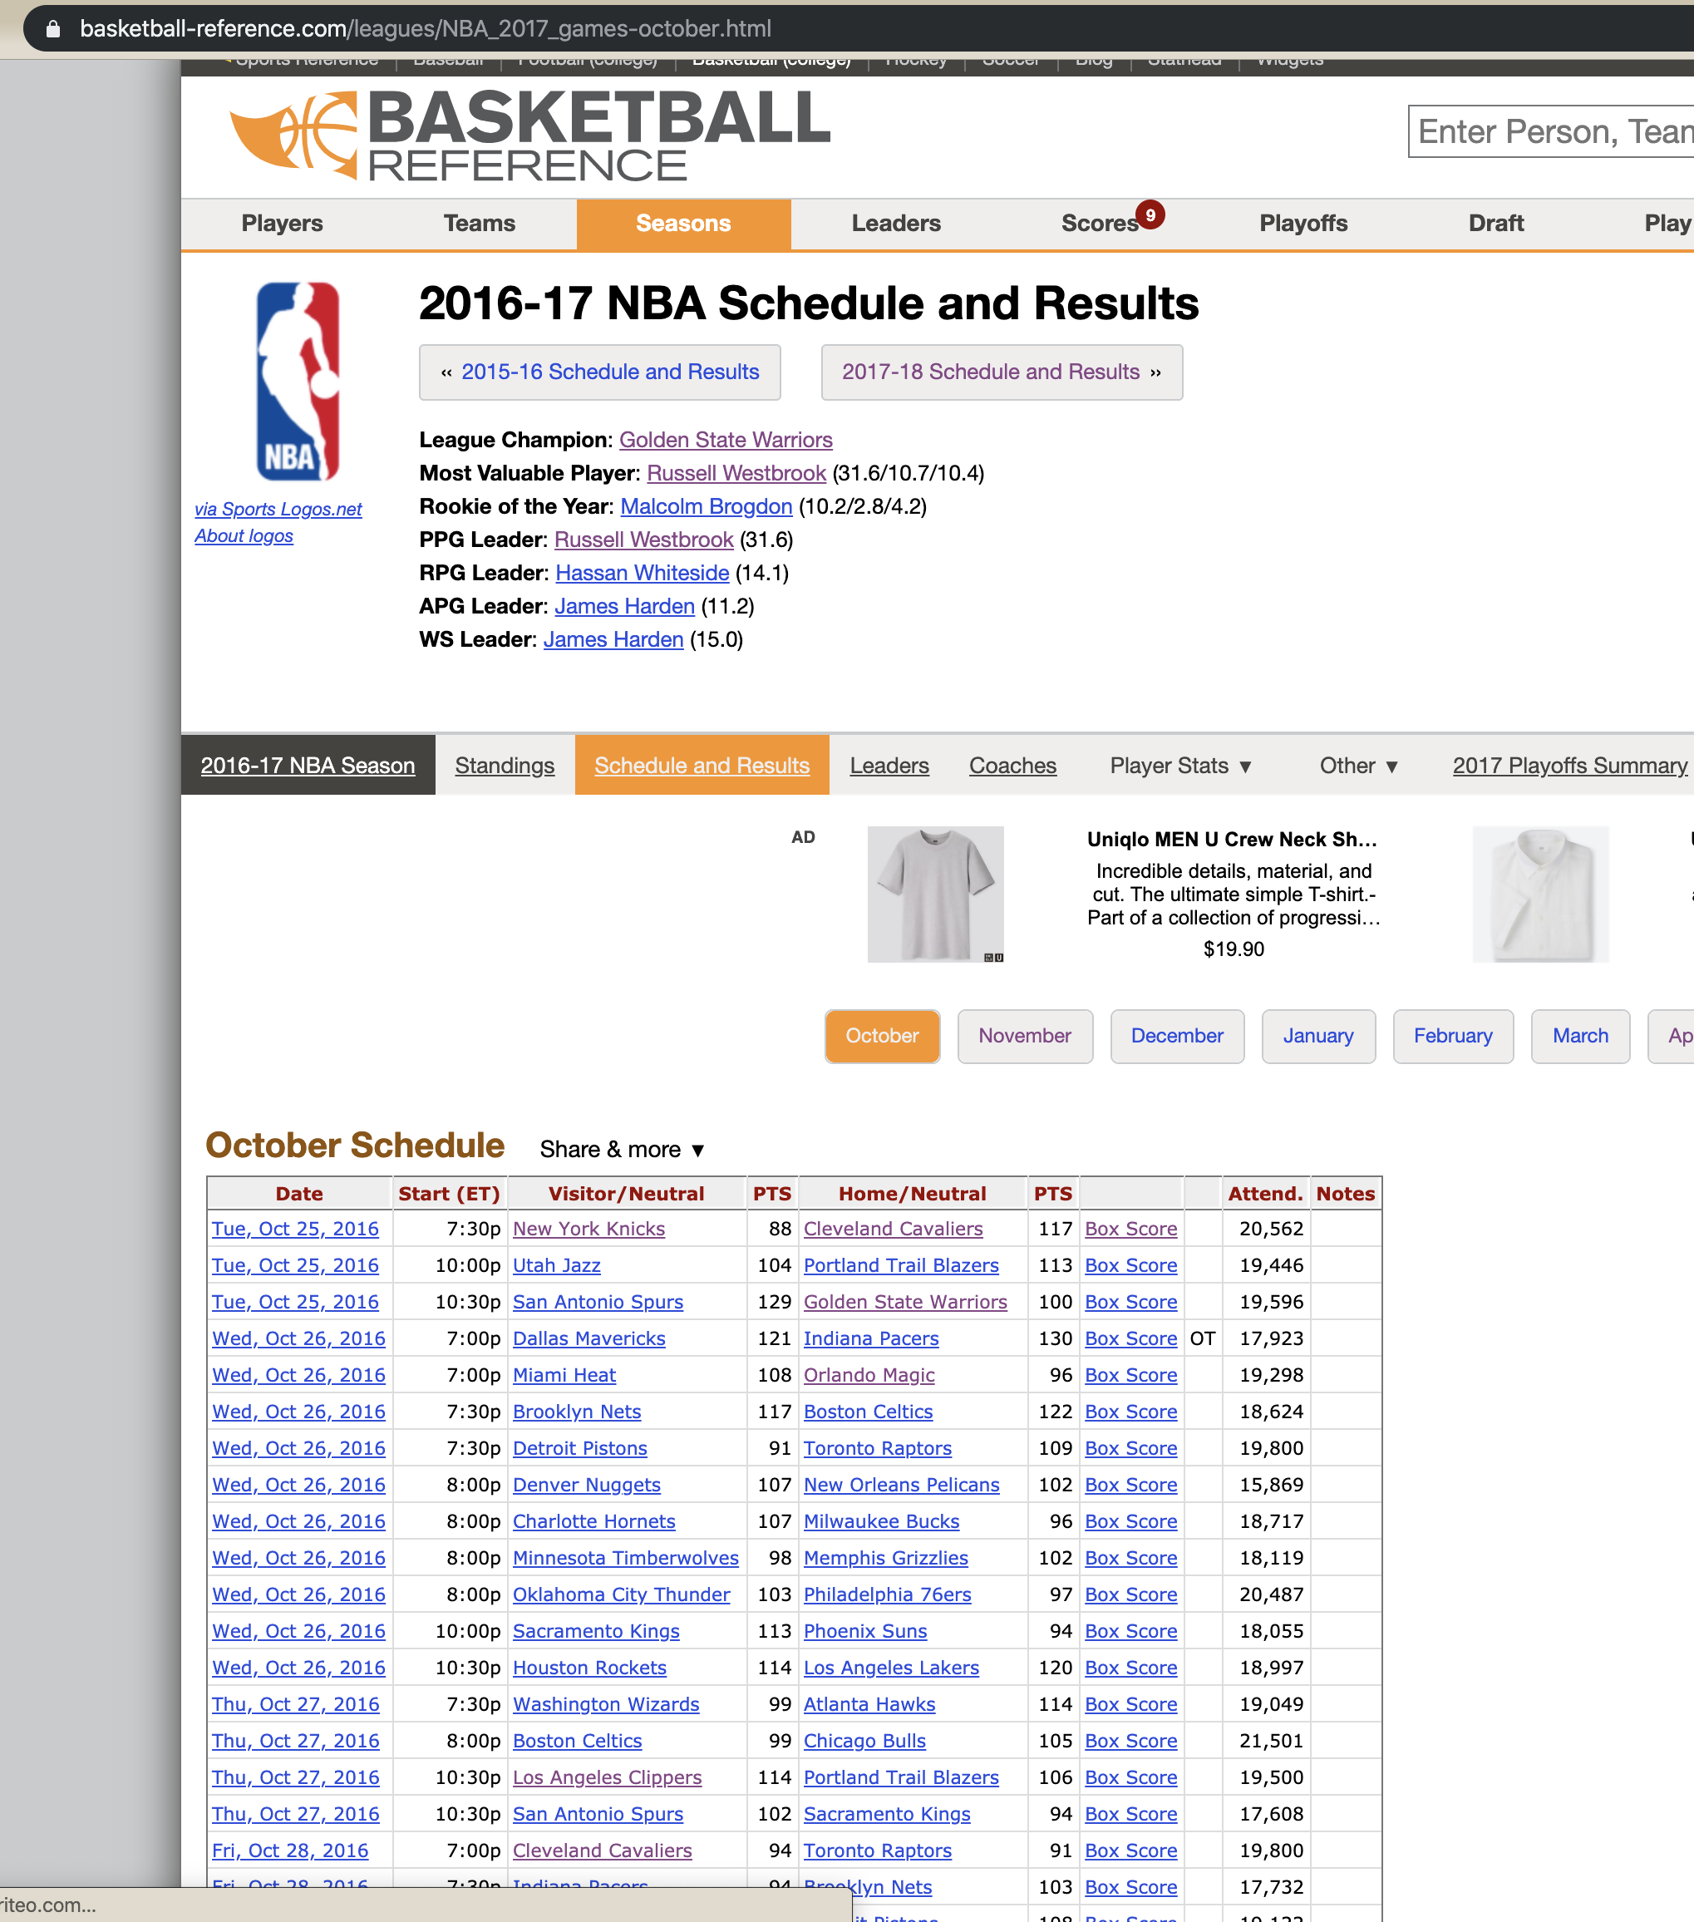

Figure 1

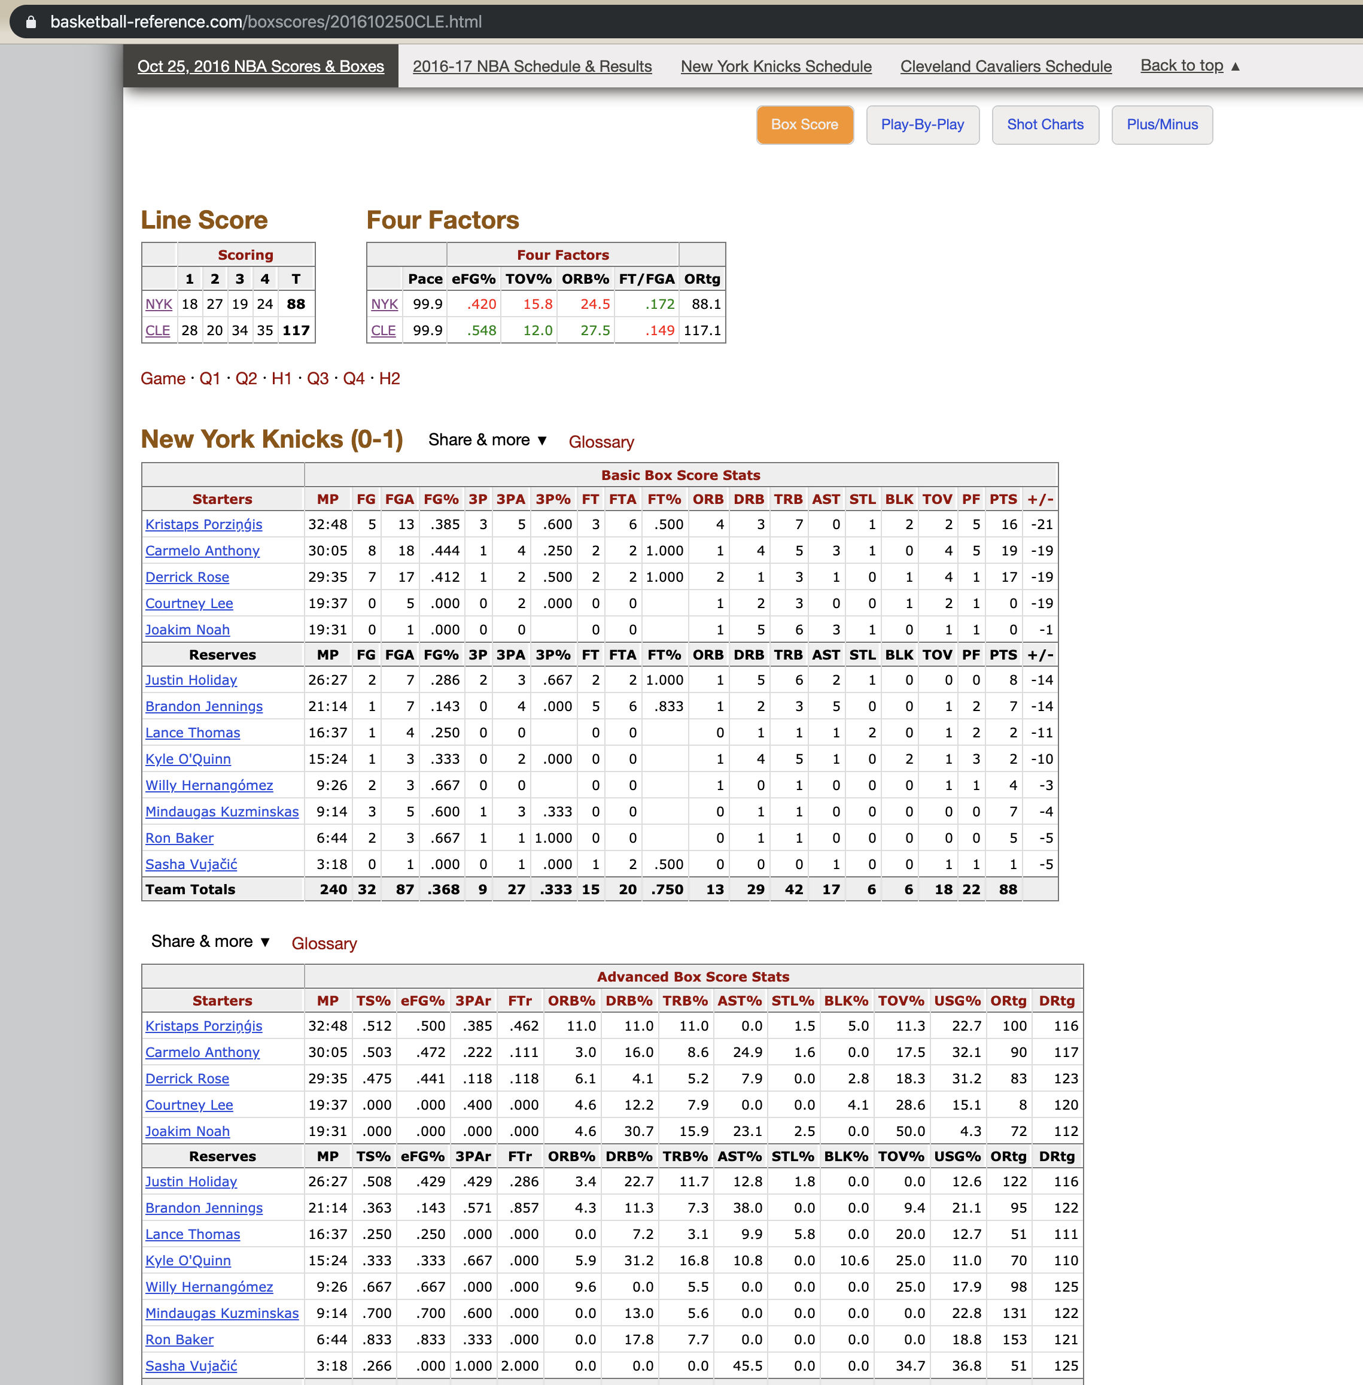

Figure 2

1. Output all data as .csv file